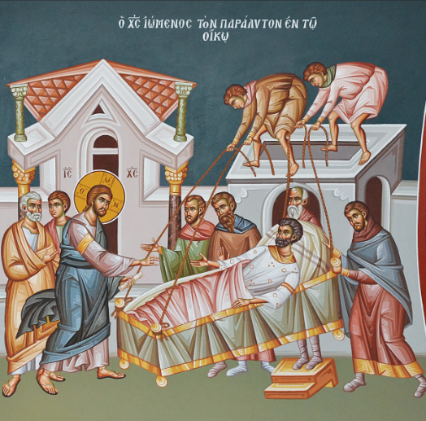
ST. NICHOLAS UKRAINIAN CATHOLIC CHURCH
Українська Греко-Католицька Церква Святого Миколая

Sunday, March 1, 2026
Second Sunday of the Great Fast: St. Gregory Palamas; The Holy Venerable-Martyr Eudocia.
1 березня
2-а Неділя Посту

WELCOME TO ST. NICHOLAS PARISH

9507 Austin O'Brien Road, Edmonton, Alberta, T6B 2C1
Parish Priest: Fr. Slavko Dumeč (о. Славко Думич) Home Phone: 780-467-6200
Email: fr.dumec@eeparchy.com +Parish Website www.stnicholasucp.ca

Sunday services are: Rosary at 9:30 AM and Divine Liturgy at 10:00 AM
Недільні богослужіння: Вервиця о 9:30 та Божественна літургія о 10:00
Week day Divine Liturgy is on Wednesday morning at 10:00 AM
У будній день Божественна Літургія – у середу вранці о 10:00
+ For feast days services and events please check regularly our website or our bulletin
+Confessions - Every Sunday at 9:15 a.m., or by previous arrangement with Father Slavko. Сповідь - кожної неділі о 9:15 або за попередньою домовленістю з о. Славком.
+Please make arrangements for Baptisms in advance with the pastor.
+Pre-marriage classes are a pre-requisite to Matrimony. Please register at least 6 months prior to the wedding day.
+Anointing of the Sick - for healing and recovery, in all cases of surgery and grave illness (spiritual or physical), please call Fr. Slavko directly.
+OUTREACH: Here at St. Nicholas Parish, we are one Body in Christ. If you or someone you know, is ill, lonely, or grieving, please contact Emily Dolynchuk, who will coordinate a visit or call. Her phone number is (780) 469-4083 or call Fr. Slavko
The email is: outreach.stnicholasucp@gmail.com
+Eparchial Website: www.edmontoneparchy.com
+Youth and Family Ministry Website: www.saintnicksyouth.com

PARISH MISSION STATEMENT:
THE FAITHFUL OF ST. NICHOLAS PARISH ARE CALLED TO JOYFULLY LEAD THE LIFE TAUGHT BY THE RISEN CHRIST, REACHING OUT WITH LOVE AND COMPASSION AS DID OUR PATRON SAINT - ST. NICHOLAS, ARCHBISHOP OF MYRA - AND PROCLAIMING CHRIST'S WORD TO ALL PEOPLE FOR THE GLORY OF GOD

DIVINE LITURGY PROPERS FOR SECOND SUNDAY OF GREAT FAST
Неділя святого отця нашого Григорія Палами; Св. прпмц. Євдокії. Літургія св. Василія Великого.

Epistle Readers: Emily Dolynchuk in English and Stefan Hrupa Ukrainian
Troparion, Tone 5: Let us the faithful acclaim and worship the Word,* co-eternal with the Father and the Spirit,* and born of the Virgin for our salvation.* For He willed to be lifted up on the cross in the flesh, to suffer death* and to raise the dead by His glorious resurrection.
Glory be to the Father and to the Son and to the Holy Spirit, now and for ever and ever. Amen.
Kontakion, Tone 4: The time for action is now revealed;* the Judge is at the door.* Let us rise and keep the fast,* offering tears of contrition with alms and crying aloud:* our sins are more numerous than the sands of the sea,* but forgive us, O Maker of all, that we may receive incorruptible crowns.
Prokeimenon, Tone 5: You, O Lord, will guard us* and will keep us* from this generation* and forever.
verse: Save me, O Lord, for there is no longer left a just man. (Psalm 11:8,2)

A reading from the Epistle of the Holy Apostle Paul to the Hebrews
Brothers and Sisters, “In the beginning, Lord, you founded the earth, and the heavens are the work of your hands; they will perish, but you remain; they will all wear out like clothing; like a cloak you will roll them up, and like clothing they will be changed.
But you are the same, and your years will never end.”
But to which of the angels has he ever said,
“Sit at my right hand until I make your enemies a footstool for your feet”?
Are not all angels spirits in the divine service, sent to serve for the sake of those who are to inherit salvation?
Therefore we must pay greater attention to what we have heard, so that we do not drift away from it. For if the message declared through angels was valid, and every transgression or disobedience received a just penalty, how can we escape if we neglect so great a salvation? It was declared at first through the Lord, and it was attested to us by those who heard him. Hebrews 1:10-2:3

Апостол: (Євр 1,10-2,3)
Браття і Сестри, «Ти, Господи, напочатку заснував землю і небеса – діло рук твоїх. Вони загинуть, ти ж перебуваєш; усі, мов одежа, постаріються. Ти їх, неначе одежину, згорнеш і, немов одежа, вони зміняться. Ти ж – той самий, і літа твої не скінчаться.» До кого з ангелів він коли мовив: «Сідай праворуч мене, доки не покладу твоїх ворогів підніжком під твої ноги?» Хіба ж не всі вони служебні духи, що їх посилають до послуг тим, які мають успадкувати спасіння? Тому ми мусимо вважати дуже пильно на те, що почули, щоб, бува, нас не знесло з дороги. Бо коли слово, оголошене ангелами, було таке зобов’язуюче, що всякий його переступ і непослух приймав справедливу кару, то як утечемо ми, коли занедбаємо таке велике спасіння? Воно, спочатку проповідане Господом, було підтверджене нам тими, що його чули.

Alleluia, Tone 5: Your mercies, O Lord, I will sing for ever; from generation to generation I will announce Your truth with my mouth.
verse: For You have said: Mercy shall be built up for ever; in the heavens Your truth shall be prepared. (Psalm 88:2,3)

Gospel Mark 2:1-12
At that time, Jesus returned to Capernaum after some days, and it was reported that he was at home. So many gathered around that there was no longer room for them, not even in front of the door; and he was speaking the word to them. Then some people came, bringing to him a paralyzed man, carried by four of them. And when they could not bring him to Jesus because of the crowd, they removed the roof above him; and after having dug through it, they let down the mat on which the paralytic lay. When Jesus saw their faith, he said to the paralytic, “Son, your sins are forgiven.” Now some of the scribes were sitting there, questioning in their hearts, “Why does this fellow speak in this way? It is blasphemy! Who can forgive sins but God alone?” At once Jesus perceived in his spirit that they were discussing these questions among themselves; and he said to them, “Why do you raise such questions in your hearts? Which is easier, to say to the paralytic, ‘Your sins are forgiven,’ or to say, ‘Stand up and take your mat and walk’? But so that you may know that the Son of Man has authority on earth to forgive sins”—he said to the paralytic— “I say to you, stand up, take your mat and go to your home.” And he stood up, and immediately took the mat and went out before all of them; so that they were all amazed and glorified God, saying, “We have never seen anything like this!”

Євангеліє: (Мр 2,1-12)
У той час коли прийшов Ісус до Капернауму, чутка пішла, що він у домі. І там зібралося стільки народу, що не було більш місця, навіть перед дверима; а він промовляв до них словом. І от прийшли до нього, несучи розслабленого; несли його четверо. А що із-за народу не могли донести до нього, розкрили стелю над місцем, де він був, й отвором спустили ліжко, на якому лежав розслаблений. Ісус, уздрівши їхню віру, до розслабленого й каже: “Сину, відпускаються тобі твої гріхи.” А були й деякі книжники, що сиділи там та міркували собі: “І як може цей так говорити? Він богохульствує! Хто може прощати гріхи, крім одного лише Бога?” Ісус же, вмить збагнувши духом, що вони таке собі думають, до них і каже: “Чого таке ось намислюєте у ваших серцях? Що легше – сказати розслабленому: Відпускаються тобі гріхи, а чи сказати: Встань, візьми твоє ліжко й ходи? Та щоб ви знали, що Син Чоловічий має владу на землі гріхи відпускати, – мовить до розслабленого: Кажу тобі: Встань, візьми твоє ліжко і йди до свого дому.” Устав той – і зараз же, взявши ліжко, вийшов на очу всіх; тож чудувалися всі, хвалили Бога й мовляли: “Ніколи ми такого не бачили!”

Communion Hymn: Praise the Lord from the heavens;* praise Him in the highest.* Alleluia, alleluia,* alleluia. (Psalm 148:1)

WE INVITE ALL THE PARISHIONERS AND VISITORS TO JOIN US IN THE PARISH FOYER AFTER THE DIVINE LITURGY FOR COFFEE, GOODIES AND FELLOWSHIP!

ЗАПРОШУЄМО ВСІХ ПАРАФІЯН ТА ГОСТЕЙ НАШОЇ ПАРАФІЇ ПІСЛЯ БОЖЕСТВЕННОЇ ЛІТУРГІЇ ПРИЄДНАТИСЯ ДО НАС У ФОЙЄ ПАРАФІЇ НА КАВУ, СМАКОЛИКИ ТА СПІЛКУВАННЯ!

We warmly welcome and congratulate our young member Luka Pavliuk who will received the Sacraments of Initiation today March 1 2026 after Divine Liturgy. We also extend our heartfelt blessings to his parents, Taras Paviuk and Khrystyna Hardaman.
Многая літа! May God continue to bless Luku and his family abundantly!
ST. NICHOLAS UKRAINIAN CATHOLIC CHURCH
March 2026
1  Second Sunday of Lent  Rosary - 9:30 a.m.  Divine Liturgy 10:00 a.m.  Baptism to follow | 2 |  |  | 3 |  | 4  Akathist to the Passion of Christ at 7:00 p.m. |  |  |  |  |  | 5  Divine Liturgy at Dr. Turner Lodge, Fort Saskatchewan @ 10:00 a.m |  |  |  | 6  St. Brenden School kids retreat @ 9:00 a.m.  Liturgy of the Presanctified Gifts with Panahyda @ 6:00 p.m.  Man of Integrity @  St. Albert @ 5 PM |  |  |  |  | 7  All Souls Saturday  Divine liturgy and Panahyda @10:00 a.m.  Pray Hard, Play Hard  5:30p.m. Dormition Parish (15608 - 104 Ave)  Questions about Life  Youth gathering @ St. Nicholas 6:00p.m.
8  Spring Time Change  Third Sunday of Lent – Veneration of the Holy Cross  Rosary - 9:30 a.m.  Divine Liturgy and  Annual General Meeting and Church AGM after service |  |  | 9  Хресна дорога  in UKRAINIAN and Parastas @ 6:00 p.m. |  |  |  |  |  | 10  Divine Liturgy at St. Isidore School @ 8:45a.m. |  |  |  | 11  St. Brenden School kids retreat @ 9:00 a.m.  Akafist with with Sorokousty @ 7:00 p.m. |  |  |  | 12  Divine Liturgy at South Fort Bend, Fort Saskatchewan @ 10:00 a.m.  and  Community Care @1:30 p.m. |  |  |  | 13  St. Brenden School kids retreat @ 9:00 a.m.  Liturgy of the Presanctified Gifts with Panahyda @ 7:00 p.m. |  |  | 14
15  Forth Sunday of Lent-John Climacus  Rosary - 9:30 a.m.  Divine Liturgy 10:00 a.m.  Lenten Mission  Confessions 9:00 a.m. before and after services followed by  Mothers in Prayer  The way of the Cross procession around the church @ 3:00p.m. with Mothers in Prayer |  |  |  |  |  |  |  | 16  Stations of the Cross @ 6:00 p.m.  Lenten Mission @ 7:00 p.m.  Confessions  before and after services |  |  |  |  |  | 17  Fr. Slavko in Calgary for confessions |  |  |  | 18  Stations of the Cross and Parastas/ Great Panahyda @ 6:00 p.m. |  | 19 |  | 20  Social Drop-in event  @10 a.m |  | 21
22  5th Sunday of Lent  Rosary - 9:30 a.m.  Divine Liturgy 10:00 a.m.  Thank you to Fr. Ivan Slavych for replacing Fr. Slavko today |  |  | 23 |  |  |  | 24 |  |  | 25  Feast of the Annunciation of the Mother of God  Divine Liturgy @ 7:00 p.m |  |  |  |  | 26  Divine Liturgy at Ottewell Place Lodge @ 10:00 a.m  St. Nicholas hosting Newman Collage Lecture starting with vespers @ 6:00 p.m. |  |  |  | 27  Social Drop-in event  @10 a.m |  |  |  | 28  COR Prayer and coffee starting with Divine Liturgy @ 9 a.m.
29  Palm Sunday  Rosary - 9:30 a.m Divine Liturgy 10:00 a.m.  Blessing of  Pussy willows  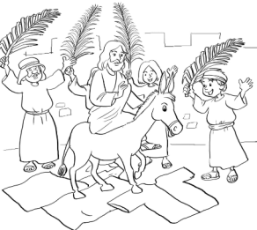 |  | 30 |  |  | 31  Divine Liturgy at St. Isidore School @ 8:45a.m.  Akafist to the Passion of Christ @ 7:00 p.m.  Confessions before and after services |  |  |  |  |  | April 1  Хресна дорога  in UKRAINIAN and Parastas @ 6:00 p.m.  Confessions before and after services |  |  |  | 2  Holy Thursday Vespers with the Liturgy of Saint Basil the Great @10:00 AM at Saint Josaphat’s Cathedral ?  Matins of the Passion of Christ and the Rite of Washing of the Disciples’ Feet @ 7:00 PM & Setting the Place for the Holy Shroud, Божий Гріб righ after Matins |  |  |  | 3  Holy / Good Friday  Great Vespers with the Laying of the Shroud Виставлення Плащаниці @ 11:00 a.m.  Jerusalem Matins @ 7:00 p.m. also called Nadhrobne |  |  |  | 4  Holy Saturday Vespers with the Divine Liturgy of St. Basil the Great @ 12:30 p.m.  followed by Blessing of Paschal Food around 2 p.m.  Nadhrobne @ 7:00 p.m.

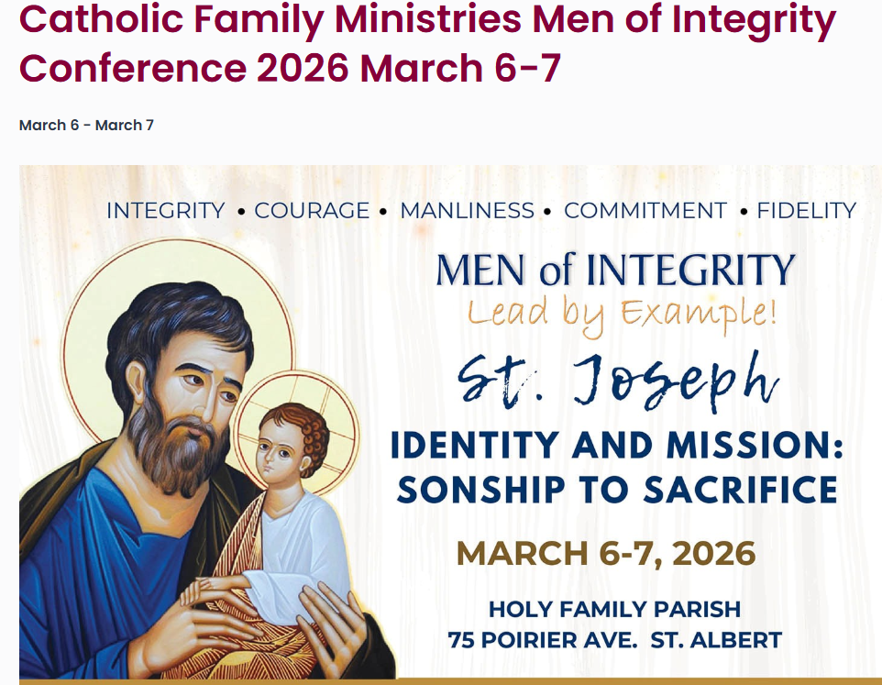

Men of our parish are invited and encouraged to attend the upcoming Catholic Men’s Conference. This is a wonderful opportunity to grow in faith, strengthen brotherhood, and connect with other men from across the Archdiocese and Eparchy.
For more information and to register, please visit:
www.catholicfamilyministries.com
Let us continue our Lenten journey together in strength and integrity.

Pray Hard, Play Hard
Young adults (ages 18-35) are invited to our next event on Saturday, March 7th at 5:30pm. Join us at Dormition Parish (15608 - 104 Ave) for Vespers followed by Pysanky writing. We will provide all the supplies. If you’re able, a small cash contribution to help cover the cost of food is appreciated. We hope you can join us!

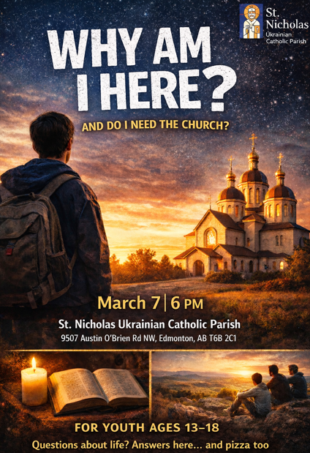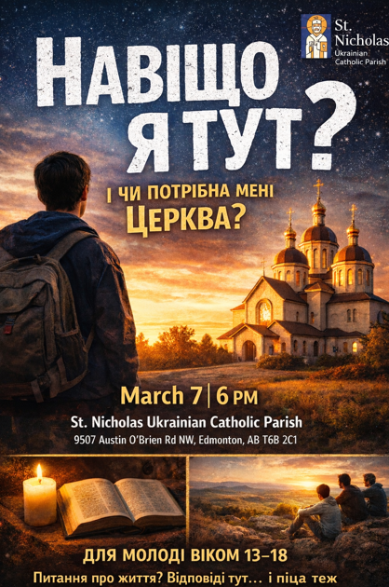

Зустріч молоді на парафії св. Миколая відбудеться у Суботу, 7 березня, о 18:00. Запрошуємо молодь віком 13–18 років на зустріч з темою: «Навіщо я тут і чи потрібна мені Церква?». Програма включає коротку молитву, презентацію та діалогове обговорення, а також неформальне спілкування з піцою та напоями. Зустріч (ймовірно) проходитиме українською мовою. Головний організатор — семінарист Марко Коваль. Заохочуємо підлітків запрошувати своїх друзів, а парафію — підтримати цю ініціативу.

Youth Gathering at St. Nicholas Parish will take place on Friday, March 7 at 6:00 PM. Youth ages 13–18 are invited to a gathering on the theme “Why am I here, and do I need the Church?”. The evening will include a short prayer, a presentation with open dialogue, and a relaxed time with pizza and drinks. The meeting will be held most likely in Ukrainian. Main organizer: seminarian Marko Koval. Youth are encouraged to invite friends, and parishioners are invited to support this initiative.

Beginning in February, St. Nicholas Parish started hosting a Social Drop-in event every Friday from 10 AM to 12:00 PM in the church basement. Attendees can participate in various activities or just visit and have coffee. We can organize transportation for those who need a ride. Contact Barb Olynyk 780 722 3537

Join us for Mary's Way of the Cross.
Every Friday during the Great Fast at 9:45 am. No book necessary. Everything will be projected on the screen.
https://us05web.zoom.us/j/82031154173?pwd=S3MvK0Y4SG11eTRoR0RsNzFVLzVzdz09
Everyone welcome.

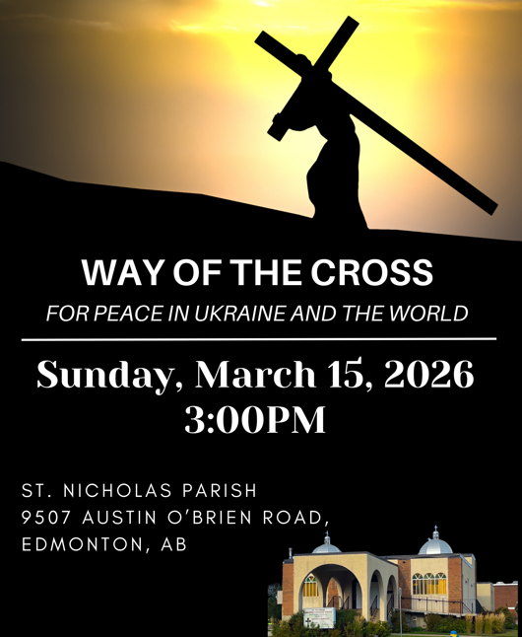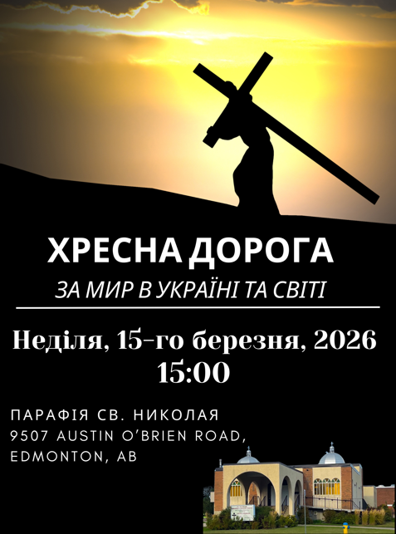



Please remember that on Sunday, March 8, 2026, Daylight Saving Time begins—please move your clocks ahead one hour before coming to church.

Нагадуємо, що в неділю, 8 березня 2026 року, розпочинається перехід на літній час, тому просимо перевести годинники на одну годину вперед перед тим, як вирушати до храму.

First Confession and First Solemn Communion
Preparation Classes
If your child is 7 years old (Grade 2) or has not yet received their First Confession and First Solemn Communion, please contact Damian Rudiak or Fr. Slavko to register your child.
Children will receive their First Confession and First Solemn Communion on Pentecost Sunday and must attend preparation classes prior to this day. Approximately 12 hours of class time are required to ensure proper spiritual and catechetical preparation.
Today, Sunday, will be the first gathering for children registered for First Communion preparation.
This will be a shorter introductory meeting, during which we will review expectations and outline the schedule.
Parents are asked to attend as well.
Please gather in the Bozhi Dity room following fellowship, as important information will be shared with parents.
Classes will continue on Sundays following the Divine Liturgy.

Перша Сповідь і Перше Урочисте Святе Причастя
Підготовчі заняття
Якщо вашій дитині виповнилося 7 років (2 клас) або вона ще не приступала до Першої Сповіді та Першого Урочистого Святого Причастя, просимо звернутися до Дам’яна Рудяка або о. Славка для реєстрації.
Діти приступлять до Першої Сповіді та Першого Урочистого Святого Причастя у неділю П’ятидесятниці і повинні пройти підготовчі заняття до цього дня. Для належної духовної та катехитичної підготовки передбачено приблизно 12 годин занять.
Сьогодні, у неділю, відбудеться перша зустріч для дітей, зареєстрованих на підготовку до Першого Причастя.
Це буде коротка вступна зустріч, під час якої буде пояснено очікування та представлено розклад занять.
Батьків також просимо бути присутніми.
Після братерського спілкування зберіться, будь ласка, у кімнаті «Божі Діти», де буде подано важливу інформацію для батьків.
Подальші заняття відбуватимуться щонеділі після Божественної Літургії.

Parish Outreach / Парафіяльне служіння
Bishop David has initiated a program called “Always Our Parishioners” for the Eparchy of Edmonton. To support this program in our parish, we would like to partner with the Outreach Committee of our UCWLC branch to visit those who are unable to come to church but are still an important part of our parish community.
We are inviting parishioners of all ages and genders to volunteer for this St. Nicholas outreach program. If you are interested, please sign up in the foyer or contact Barb Olynyk at 780-722-3527 or bdolynyk@gmail.com.
In the new year, we will meet to discuss how this program will operate.

Владика Давид започаткував програму «Завжди наші парафіяни» для Едмонтонської єпархії. На підтримку цієї програми в нашій парафії ми хотіли б співпрацювати з Комітетом служіння нашого відділу UCWLC, щоб відвідувати тих, хто не може приходити до церкви, але й надалі залишається важливою частиною нашої парафіяльної спільноти.
Запрошуємо парафіян усіх вікових груп і статей долучитися як волонтери до програми парафіяльного служіння святого Миколая. Якщо ви зацікавлені, будь ласка, запишіться у притворі церкви або звертайтеся до Барбари Олиник за телефоном 780-722-3527 або електронною поштою bdolynyk@gmail.com.
У новому році відбудеться зустріч для обговорення того, як діятиме ця програма.

“Fruits of the Holy Spirit” Online Retreat for Catechists and those aspiring to be catechists.
Session Dates:
• Ukrainian: March 2 & 9
• English: March 3 & 10
Time: 7:00 p.m. (CST) / 6:00 p.m. (18:00) MST (Mountain Standard Time) in Edmonton
To register and receive a link, please email: catechistugcc@gmail.com

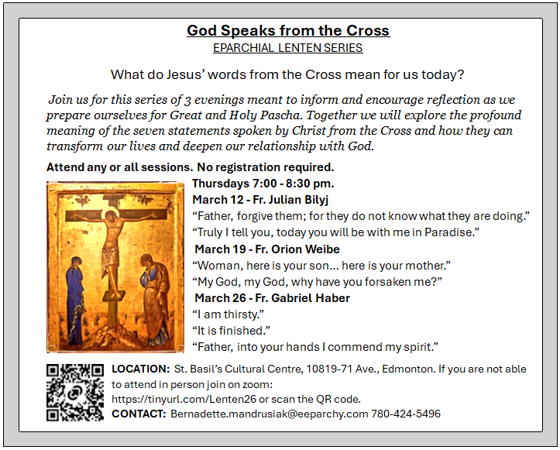

Healing Wounds of War: Aid for Ukraine through The Eparchy of Edmonton & CNEWA
From the first days of the war, the Eparchy of Edmonton, together with our partner Catholic Near East Welfare Association (CNEWA), has supported urgent aid for the people of Ukraine. Donations help provide humanitarian, pastoral, and educational support for those in crisis.
As we approach 2026, your help makes a difference in key priorities such as:
· Delivering essential food, medical care, and shelter to those in dire need.
· Supporting displaced families with safe living arrangements and psychological assistance for children traumatized by war.
· Caring for wounded soldiers and those who lack health care: Caritas Ukraine is expanding a network of medical centers for displaced families and residents.
· Formation programs in seminaries and clergy formation for medical and military chaplaincy.
· Child care initiatives, including education and the integration of refugee children.
CNEWA partners include Caritas Ukraine, the Ukrainian Greek Catholic Church, and Ukrainian Catholic University, working together to heal wounds, restore dignity, and share hope. To help those in need, you can donate through your local parish, the Eparchy of Edmonton, or directly via CNEWA. Thank you for supporting the people of Ukraine in their time of need.

Annual General Meeting – March 8, 2026
On Sunday, March 8, 2026, immediately following the Divine Liturgy, we will hold our Annual General Meeting (AGM) in the parish hall.
All parishioners are encouraged to attend. This is an important opportunity to review the past year, discuss parish matters, and look ahead with hope and responsibility as a parish family.
Please plan to stay and participate. Your presence and voice matter.

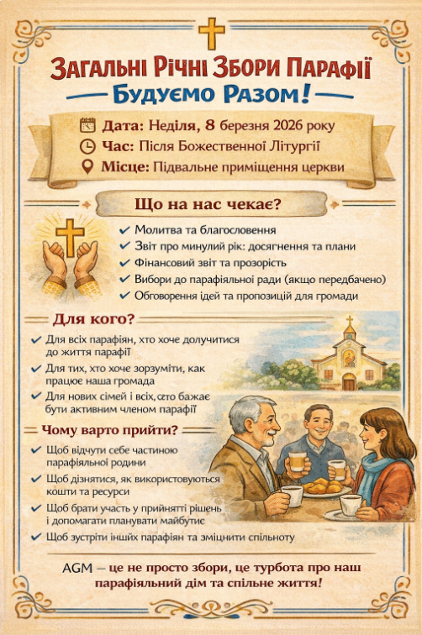

During Great Lent, the Eparchy of Edmonton conducts its annual collection for “Aid to the Missionary Church in Canada.” The purpose of this collection is to support the needs of the Church in Canada. Three charitable institutions are the recipients of the collection: the Ukrainian Catholic Church in Alberta, Catholic Missions in Canada, and the Canadian Conference of Catholic Bishops.

The Ukrainian Catholic Church in Alberta responds to the call of Christ to “make disciples of all nations, baptizing them in the name of the Father and of the Son and of the Holy Spirit, and teaching them to obey everything that I have commanded you” (Matthew 28: 19-20). The Eparchy of Edmonton supports local priests in their travel, health care, pension, and clergy substitution, thus ensuring that they can respond to the pastoral needs of the faithful, especially the celebration of the Divine Liturgy and funerals in rural Alberta. Visit www.edmontoneparchy.com to see how the Church is working for you.

Catholic Missions in Canada supports over 600 missionaries – priests, deacons, sisters, brothers and lay ministers – throughout 27 eparchies and dioceses right here in Canada, including the Ukrainian Catholic Church. Catholic Missions supports the local churches in our call to proclaim the Gospel among First Nations communities, missionary support, religious education programs, building and repairs, lay pastoral leadership programs, and the education of seminarians. To learn more about the work of Catholic Missions in Canada, visit (www.cmic.info) and sign up for a free subscription to its quarterly magazine by calling toll-free 1-866-937-2642.

Each year, the Canadian Conference of Catholic Bishops is asked to speak out, give leadership, and provide guidelines for the faithful on a wide variety of topics in our daily lives. For our bishops to do so, they must have the benefit of research and expert advice. Research and gathering information require staff, time and money. Through the yearly bishops’ collection, an appeal is made to all Catholics to be generous towards the work of their bishops. To learn more about the Canadian Conference of Catholic Bishops, visit www.cccb.ca

Newman Theological College Public Lecture – March 25
Dr. Melanie Turgeon presents “Pray and Give Praise: The Choral Tradition of the Eastern Church” on March 25, 6:00–7:00 PM (GMT), as part of the Maryvale Orientale Lumen Lectures. Join live via Microsoft Teams (see link on the poster on the bulletin board).

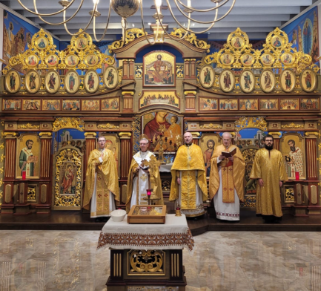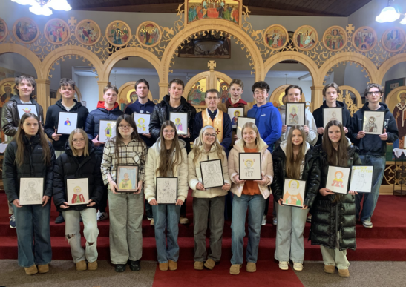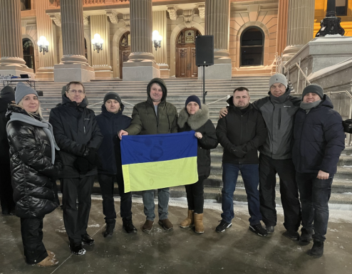

Thank you to all, especially any visitors, for coming and praying with us for first time!
Please come again and become part of our joyful Church family.

Дякуємо всім, особливо ми вдячні тим, що вперше прийшли і молилися разом з нами!
Будь ласка, приходьте знову і станьте частиною нашої церковної родини

Prayer of Saint Ephrem
O Lord and Master of my life! Drive from me the spirit of indifference and discouragement, lust of power, and idle chatter. (Prostration)

Instead, grant to me, Your servant, the spirit of integrity, humility, patience, and love. (Prostration)

Yes, O Lord and King! Let me see my own sins, and not judge my brothers and sisters; for You are blessed, for ever and ever. Amen. (Prostration)

(Then with a simple bow, the following is repeated 4 times)
+ God, be merciful to me a sinner.
+ God, cleanse me of my sins and have mercy on me.
+ I have sinned without number, forgive me, O Lord!

(Once more the entire prayer of St. Ephrem is recited without the usual prostrations. One prostration is made at the conclusion)

Молитва Святого Єфрема
Господи і Владико життя мого! Духа лінивства,
недбайливости, властолюб'я і пустомовства
віджени від мене. (Доземний поклін)
Духа чистоти, покори, терпеливости й любови
даруй мені, слузі твоєму. (Доземний поклін)
Так, Господи, Царю! Дай мені бачити гріхи мої
і не осуджувати брата мого і сестру мою, бо ти благословенний
на віки вічні. Амінь. (Доземний поклін)
(Відтак проказуємо слідуючу молитву 4 рази з метанією)
+ Боже милостивий будь мені грішному!
+ Боже очисти гріхи мої і помилуй мене!
+ Без числа нагрішив(шила) я, Господи прости мені!
(Знову проказуємо молитву св. Єфрема без поклонів. Проказавши молитву робимо ще один поклін)

