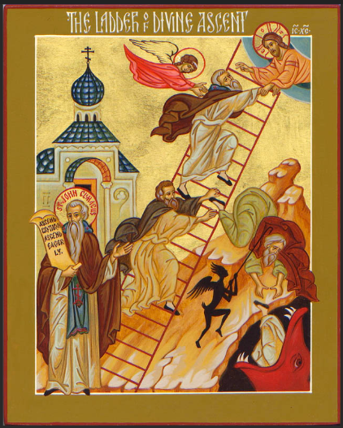
ST. NICHOLAS UKRAINIAN CATHOLIC CHURCH
Українська Греко-Католицька Церква Святого Миколая
Sunday, March 15, 2026
Fourth Sunday of the Great Fast:
St. John Climacus; The Holy Martyr Agapius and the Six Martyrs with him.
15 березня - Неділя 4-тя Великого Посту

WELCOME TO ST. NICHOLAS PARISH

9507 Austin O'Brien Road, Edmonton, Alberta, T6B 2C1
Parish Priest: Fr. Slavko Dumeč (о. Славко Думич) Home Phone: 780-467-6200
Email: fr.dumec@eeparchy.com +Parish Website www.stnicholasucp.ca

Sunday services are: Rosary at 9:30 AM and Divine Liturgy at 10:00 AM
Недільні богослужіння: Вервиця о 9:30 та Божественна літургія о 10:00
Week day Divine Liturgy is on Wednesday morning at 10:00 AM
У будній день Божественна Літургія – у середу вранці о 10:00
+ For feast days services and events please check regularly our website or our bulletin
+Confessions - Every Sunday at 9:15 a.m., or by previous arrangement with Father Slavko. Сповідь - кожної неділі о 9:15 або за попередньою домовленістю з о. Славком.
+Please make arrangements for Baptisms in advance with the pastor.
+Pre-marriage classes are a pre-requisite to Matrimony. Please register at least 6 months prior to the wedding day.
+Anointing of the Sick - for healing and recovery, in all cases of surgery and grave illness (spiritual or physical), please call Fr. Slavko directly.
+OUTREACH: Here at St. Nicholas Parish, we are one Body in Christ. If you or someone you know, is ill, lonely, or grieving, please contact Emily Dolynchuk, who will coordinate a visit or call. Her phone number is (780) 469-4083 or call Fr. Slavko
The email is: outreach.stnicholasucp@gmail.com
+Eparchial Website: www.edmontoneparchy.com
+Youth and Family Ministry Website: www.saintnicksyouth.com

PARISH MISSION STATEMENT:
THE FAITHFUL OF ST. NICHOLAS PARISH ARE CALLED TO JOYFULLY LEAD THE LIFE TAUGHT BY THE RISEN CHRIST, REACHING OUT WITH LOVE AND COMPASSION AS DID OUR PATRON SAINT - ST. NICHOLAS, ARCHBISHOP OF MYRA - AND PROCLAIMING CHRIST'S WORD TO ALL PEOPLE FOR THE GLORY OF GOD

DIVINE LITURGY PROPERS FOR FOURTH SUNDAY OF GREAT FAST
Літургія св. Василія Великого.

Epistle Readers: Michael Lewchuk in English and Oksana Shubert in Ukrainian
Troparion, Tone 7: By Your cross You destroyed death;* You opened Paradise to the thief;* You changed the lamentation of the myrrh-bearers to joy,* and charged the apostles to proclaim* that You are risen, O Christ our God,* offering great mercy to the world.
Troparion, Tone 1: O John, our God-bearing father,* you were shown to be a citizen of the desert,* an angel in bodily form,* and a worker of miracles.* Through fasting, prayers and vigils you received heavenly gifts* to heal the sick and the souls of those who, in faith, run to you.* Glory to Him who gives you strength.* Glory to Him who crowned you.* Glory to Him who works healing for all through you.
Glory be to the Father and to the Son and to the Holy Spirit, now and for ever and ever. Amen.
Kontakion, Tone 4: On the heights of true abstinence,* the Lord established you as a reliable star,* giving light for guidance to the ends of the earth,* O father John, our teacher.

Prokeimenon, Tone 7: The Lord will give strength to His people;* the Lord will bless His people with peace.
verse: Bring to the Lord, O you sons of God; bring to the Lord young rams. (Psalm 28:11,1)
Prokeimenon, Tone 7: The venerable ones will exult in glory* and they shall be joyful in their beds. (Psalm 149:5)

A reading from the Epistle of the Holy Apostle Paul to the Hebrews
Brothers and Sisters, when God made a promise to Abraham, because he had no one greater by whom to swear, he swore by himself, saying, “I will surely bless you and multiply you.” And thus Abraham, having patiently endured, obtained the promise. Human beings, of course, swear by someone greater than themselves, and an oath given as confirmation puts an end to all dispute. In the same way, when God desired to show even more clearly to the heirs of the promise the unchangeable character of his purpose, he guaranteed it by an oath, so that through two unchangeable things, in which it is impossible that God would prove false, we who have taken refuge might be strongly encouraged to seize the hope set before us. We have this hope, a sure and steadfast anchor of the soul, a hope that enters the inner shrine behind the curtain, where Jesus, a forerunner on our behalf, has entered, having become a high priest forever according to the order of Melchizedek.Hebrews 6:13-20

Апостол: Євр 6,13-20
Браття і Сестри, коли Бог учиняв Авраамові обітницю, не маючи поклястися ніким вищим, то поклявся самим собою, кажучи: «Справді поблагословлю тебе щедро й розмножу тебе вельми.» І він, завдяки довгій терпеливості, осягнув обітницю: люди клянуться більшим від себе, і всякі їхні суперечки кінчаються клятвою на ствердження. Тому й Бог, бажаючи дати спадкоємцям обітниці якнайсильніший доказ, що його рішення непорушне, вжив клятви, щоб двома незмінними речами, в яких неможливо, щоб Бог казав неправду, ми мали сильну заохоту – ми, що прибігли прийняти надію, призначену нам. В ньому маємо, неначе якір душі, безпечний та міцний, що входить аж до середини за завісу, куди ввійшов за нас, як предтеча, Ісус, ставши архиєреєм повіки, на зразок Мелхиседека.

Alleluia, Tone 7: It is good to give praise to the Lord; and to sing to Your name, O Most High.
verse: To announce Your mercy in the morning, and Your truth every night. (Psalm 91:2,3)
verse: They who are planted in the hose of the Lord shall flourish in the courts of our God. (Psalm 91:14)

Gospel Mark 9:17-31
At that time, someone from the crowd came to Jesus, bowed before him, and said, “Teacher, I brought you my son; he has a spirit that makes him unable to speak; and whenever it seizes him, it dashes him down; and he foams and grinds his teeth and becomes rigid; and I asked your disciples to cast it out, but they could not do so.” He answered them, “You faithless generation, how much longer must I be among you? How much longer must I put up with you? Bring him to me.” And they brought the boy to him. When the spirit saw him, immediately it convulsed the boy, and he fell on the ground and rolled about, foaming at the mouth. Jesus asked the father, “How long has this been happening to him?” And he said, “From childhood. It has often cast him into the fire and into the water, to destroy him; but if you are able to do anything, have pity on us and help us.” Jesus said to him, “If you are able!—All things can be done for the one who believes.” Immediately the father of the child cried out, “I believe; help my unbelief!” When Jesus saw that a crowd came running together, he rebuked the unclean spirit, saying to it, “You spirit that keeps this boy from speaking and hearing, I command you, come out of him, and never enter him again!” After crying out and convulsing him terribly, it came out, and the boy was like a corpse, so that most of them said, “He is dead.” But Jesus took him by the hand and lifted him up, and he was able to stand. When he had entered the house, his disciples asked him privately, “Why could we not cast it out?” He said to them, “This kind can come out only through prayer.”
They went on from there and passed through Galilee. He did not want anyone to know it; for he was teaching his disciples, saying to them, “The Son of Man is to be betrayed into human hands, and they will kill him, and three days after being killed, he will rise again.”

Євангеліє: Мр 9,17-31
У той час один чоловік прийшов до Ісуса і, кланяючись, йому сказав: “Учителю, привів я до тебе сина мого, що має німого духа, і де тільки його вхопить, кидає його об землю так, що піниться, скрегоче зубами, дерев’яніє. Просив я учнів твоїх, щоб його вигнали, та не змогли.” Він же у відповідь каже їм: “О роде невірний! Доки я буду з вами? Доки вас терпітиму? Приведіть но його до мене.” І привели його до нього. Скоро дух угледів його, притьмом того затряс, і повалившись той на землю, запінившися, почав качатися. Спитав же його батька: “Скільки часу, як це йому сталося?” – “З дитинства”, – відповів той. “І часто він кидає його у вогонь і в воду, щоб його погубити. Та якщо можеш, поможи нам, змилосердившись над ним.” Ісус же каже йому: “Щодо того – якщо можеш – то все можливо тому, хто вірує.” І вмить батько хлопчини викрикнув крізь сльози: “Вірю, поможи моєму невірству!” Ісус же, бачивши, що збігається народ, погрозив нечистому духові, кажучи: “Німий та глухий душе! Наказую тобі: Вийди з нього й не входь більше в нього.” І, закричавши та сильно його стрясши, вийшов з нього. І наче змертвів той, тож многі казали: “Вмер він.” Але Ісус, узявши його за руку, підвів його, і той устав. Коли ж увійшов у дім, то учні його питали його насамоті: “Чому ми не могли його вигнати?” Він відповів їм: “Цей рід нічим не можна вигнати, тільки молитвою та постом.” Вийшовши звідти, проходили крізь Галилею, і він не хотів, щоб будь-хто знав. Навчав бо своїх учнів і казав їм: “Син Чоловічий буде виданий у руки людям, і вб’ють його, і, вбитий, по трьох днях, воскресне.”
Communion Hymn: Praise the Lord from the heavens;* praise Him in the highest. (Psalm 148:1)* The just man shall be in everlasting remembrance;* of evil hearsay he shall have no fear.* Alleluia, alleluia,* alleluia. (Psalm 111:6)

WE INVITE ALL THE PARISHIONERS AND VISITORS TO JOIN US IN THE PARISH FOYER AFTER THE DIVINE LITURGY FOR COFFEE, GOODIES AND FELLOWSHIP!

ЗАПРОШУЄМО ВСІХ ПАРАФІЯН ТА ГОСТЕЙ НАШОЇ ПАРАФІЇ ПІСЛЯ БОЖЕСТВЕННОЇ ЛІТУРГІЇ ПРИЄДНАТИСЯ ДО НАС У ФОЙЄ ПАРАФІЇ НА КАВУ, СМАКОЛИКИ ТА СПІЛКУВАННЯ!

Parish Lenten Mission – Welcome Back Fr. Julian Bilyj
Today we warmly welcome back Fr. Julian Bilyj, our former parish priest, who will lead our Lenten Parish Mission. Many in our parish already know Fr. Julian and remember his pastoral service among us. We are grateful for this opportunity to gather in prayer and reflection during the holy season of the Great Fast.

Also - Tomorrow night, Monday, March 16, 2026
Confessions starting at 6:00 PM
Stations / Way of the Cross at 7:00 PM, followed by the Lenten Mission
All parishioners are warmly invited to participate in these evenings of prayer and spiritual renewal.

Великопосна Парафіяльна Місія – Ласкаво просимо о. Юліяна Білия
Щиро вітаємо у нашій парафії о. Юліяна Білия, нашого колишнього пароха, який провадитиме Великопосну Парафіяльну Місію. Більшість наших парафіян добре знають о. Юліяна і пам’ятають його душпастирське служіння серед нас. Радіємо нагоді знову разом молитися та духовно відновитися у часі Великого Посту.

Понеділок, 16 березня 2026 р.
Сповідь від 6:00 вечора
Хресна Дорога о 7:00 вечора, після чого Великопосна Місія
Запрошуємо всіх парафіян взяти участь у цих особливих духовних зустрічах.

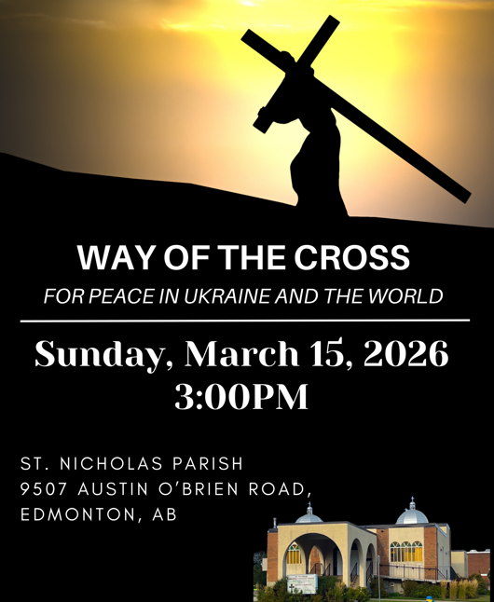 TODAY @ 3 PM 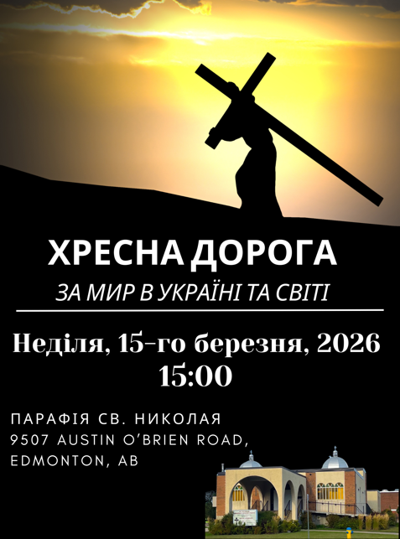
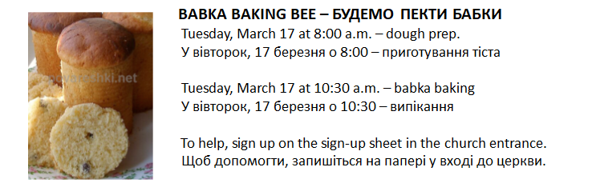

Paska Bee - Saturday March 21
Please sign up on the sign up sheet!
Thank you!!!
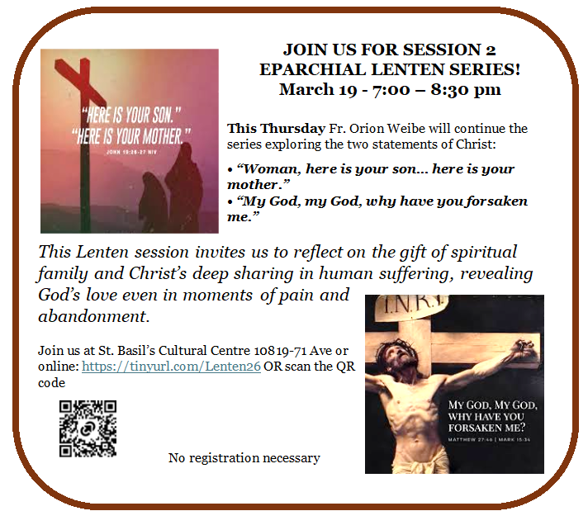

ST. NICHOLAS UKRAINIAN CATHOLIC CHURCH
March 2026
15  Forth Sunday of Lent-John Climacus  Rosary - 9:30 a.m.  Divine Liturgy 10:00 a.m.  Lenten Mission  Confessions 9:00 a.m. before and after services followed by  Mothers in Prayer  Way of the Cross - Хресна дорога  procession around the church @ 3:00p.m. with Mothers in Prayer |  |  |  |  | 16  Stations of the Cross @ 6:00 p.m.  Lenten Mission @ 7:00 p.m.  Confessions  before and after services |  |  | 17  Babka Baking BEE  @ 8 AM and 10 AM |  | 18  Stations of the Cross and Panahyda @7:00 p.m. |  |  | 19 |  | 20  Social Drop-in event  @10 a.m |  | 21  7:30 am 9:30 am  and 12:30 pm  Paska Bee
22  5th Sunday of Lent  Rosary - 9:30 a.m.  Divine Liturgy 10:00 a.m.  Thank you to Fr. Ivan Slavych  for replacing Fr. Slavko, who is away for a few days |  | 23 |  | 24 | 25  Feast of the Annunciation of the Mother of God  Divine Liturgy @ 7:00 p.m |  | 26  Divine Liturgy at Ottewell Place Lodge @ 10:00 a.m  St. Nicholas hosting Newman Collage Lecture starting with vespers @ 6:00 p.m. |  |  |  | 27  Social Drop-in event  @10 a.m |  |  | 28  COR Prayer and coffee starting with Healing Sevice Lazarus Saturday Divine Liturgy @ 9 a.m.  Annual Church Cleaning 11:15a.m.  Youth Gathering  “Holy Scripture”  @ 6:00p.m.  with seminarian Marko Koval
29  Palm Sunday  Rosary - 9:30 a.m Divine Liturgy 10:00 a.m.  Blessing of  Pussy willows  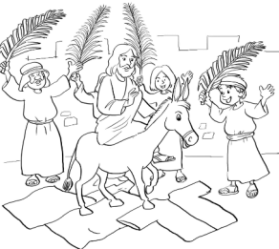 | 30 |  | 31  Divine Liturgy at St. Isidore School @ 8:45a.m.  Akafist to the Passion of Christ @ 7:00 p.m.  Confessions before and after services |  |  | April 1  Хресна дорога  in UKRAINIAN and Parastas @ 6:00 p.m.  Confessions before and after services |  |  | 2  Holy Thursday Vespers with the Liturgy of Saint Basil the Great @10:00 AM at Saint Josaphat’s Cathedral  Matins of the Passion of Christ and the Rite of Washing of the Disciples’ Feet @ 7:00 PM & Setting the Place for the Holy Shroud, Божий Гріб righ after Matins |  |  | 3  Holy / Good Friday  Great Vespers with the Laying of the Shroud Виставлення Плащаниці @ 11:00 a.m.  Jerusalem Matins @ 7:00 p.m. also called Nadhrobne |  |  |  | 4  Holy Saturday Vespers with the Divine Liturgy of St. Basil the Great @ 12:30 p.m.  followed by Blessing of Paschal Food around 2 p.m.  Nadhrobne @ 7:00 p.m.

Join us for Mary's Way of the Cross.
Every Friday during the Great Fast at 9:45 am. No book necessary. Everything will be projected on the screen.
https://us05web.zoom.us/j/82031154173?pwd=S3MvK0Y4SG11eTRoR0RsNzFVLzVzdz09
Everyone welcome.

Birthdays of the Parishioners of St. Nicholas Ukrainian Catholic Church for the month of March

Congratulations are extended from all of us at the parish to the following parishioners who are celebrating their wedding anniversaries:

March 1- Ivan and Olga Pukas
March 10 Yurij & Oksana Shchyrba
Congratulations are extended from all of us at the parish to the following parishioners who are celebrating their birthdays:
March1 - Oleg Levytskyy
March 3 – Mila Luchak Perka
March 8 - Lesia Levytsky
March 12 - Bernie Mandrusiak
March 13 - Asia Pylypova; Sviatoslav Nykolaiko
March 15 - Emmeline Hlushak; Gary Nestorowic; Colin Longhurst
March 16 - Christopher Schrettlinger; Yaroslav Hordii; Iryna Kyrylenko
March 19 – Damian Dimnych
March 26 - Ed Straty
March 27 - Brittany Horpyniuk; Bohdan Libych
March 29 - Terry Mucha
March 30 – Myroslava Pylypova
We pray to our loving Lord, through the intercession of St. Nicholas, the Wonderworker, that He continue to bless you all as you celebrate these joyous occasions. Many Happy and Blessed Years to All! Многая і Благая Літа!

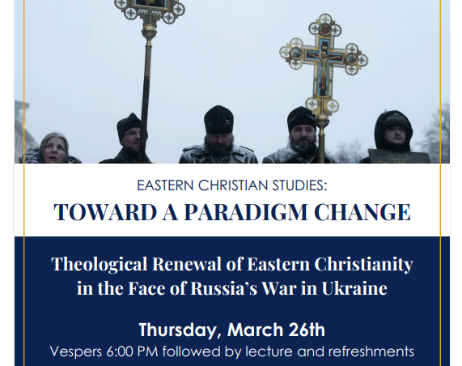

Please come to SOCIAL DROP-IN every Friday from 10:00 AM to noon in the church basement. It is a great chance to socialize and engage in any activities you choose. If you would like to come and need a ride, please contact Barb 780 722 3537. EVERYBODY WELCOME!

Будь ласка, приходьте на SOCIAL DROP-IN - захід суспільного спілкування що п'ятниці з 10:00 до 12:00 у підвалі церкви. Це чудова нагода поспілкуватися та взяти участь у будь-яких заходах на ваш вибір. Якщо ви хочете прийти і вам потрібна допомога, будь ласка, зв'яжіться з Барб за номером 780 722 3537. ЛАСКАВО ПРОСИМО ВСІХ!

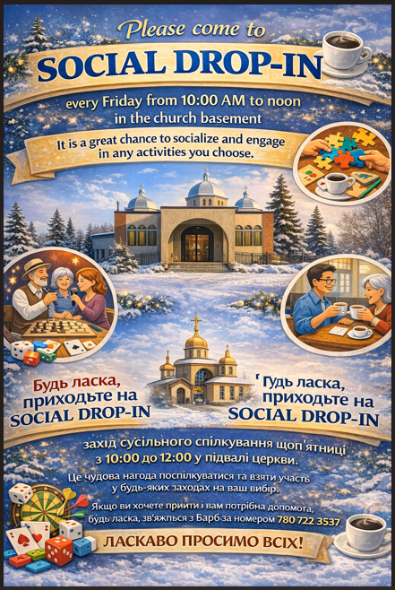

During Great Lent, the Eparchy of Edmonton conducts its annual collection for “Aid to the Missionary Church in Canada.” The purpose of this collection is to support the needs of the Church in Canada. Three charitable institutions are the recipients of the collection: the Ukrainian Catholic Church in Alberta, Catholic Missions in Canada, and the Canadian Conference of Catholic Bishops.

The Ukrainian Catholic Church in Alberta responds to the call of Christ to “make disciples of all nations, baptizing them in the name of the Father and of the Son and of the Holy Spirit, and teaching them to obey everything that I have commanded you” (Matthew 28: 19-20). The Eparchy of Edmonton supports local priests in their travel, health care, pension, and clergy substitution, thus ensuring that they can respond to the pastoral needs of the faithful, especially the celebration of the Divine Liturgy and funerals in rural Alberta. Visit www.edmontoneparchy.com to see how the Church is working for you.

Catholic Missions in Canada supports over 600 missionaries – priests, deacons, sisters, brothers and lay ministers – throughout 27 eparchies and dioceses right here in Canada, including the Ukrainian Catholic Church. Catholic Missions supports the local churches in our call to proclaim the Gospel among First Nations communities, missionary support, religious education programs, building and repairs, lay pastoral leadership programs, and the education of seminarians. To learn more about the work of Catholic Missions in Canada, visit (www.cmic.info) and sign up for a free subscription to its quarterly magazine by calling toll-free 1-866-937-2642.

Each year, the Canadian Conference of Catholic Bishops is asked to speak out, give leadership, and provide guidelines for the faithful on a wide variety of topics in our daily lives. For our bishops to do so, they must have the benefit of research and expert advice. Research and gathering information require staff, time and money. Through the yearly bishops’ collection, an appeal is made to all Catholics to be generous towards the work of their bishops. To learn more about the Canadian Conference of Catholic Bishops, visit www.cccb.ca

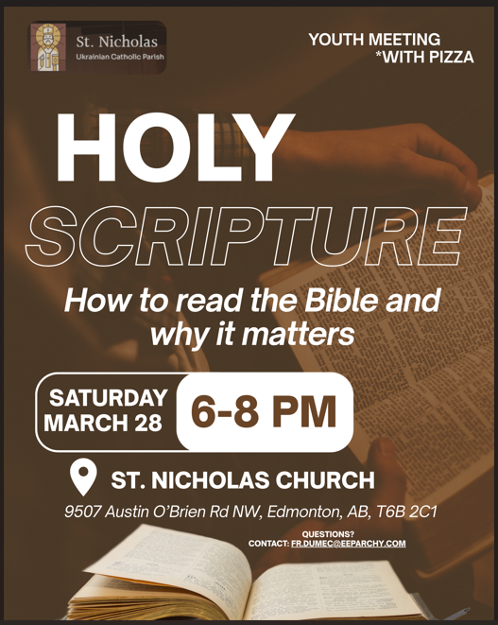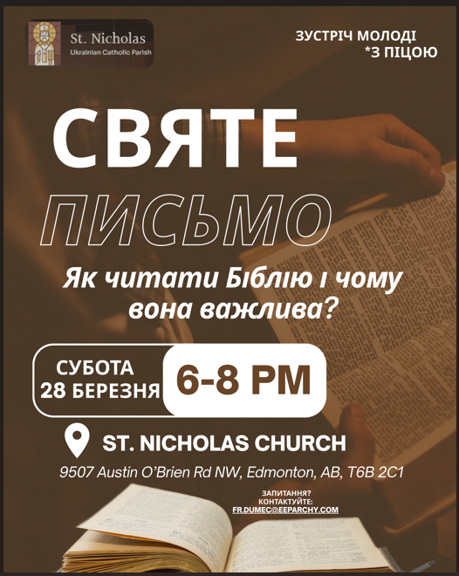

Newman Theological College Public Lecture – March 25
Dr. Melanie Turgeon presents “Pray and Give Praise: The Choral Tradition of the Eastern Church” on March 25, 6:00–7:00 PM (GMT), as part of the Maryvale Orientale Lumen Lectures. Join live via Microsoft Teams (see link on the poster on the bulletin board).

Easter Sviachene Dinner / Brunch
Sunday, April 12, 2026 — Church Hall / Basement
Everyone is invited! Please sign up so we know how many to prepare. Donations for the meal accepted (Silver Plate).
Sign-up sheet: today, Sunday, March 15, in the church foyer.
Великоднє Свячене — обід
Неділя, 12 квітня 2026 р. — Зала церкви / підвал
Усіх запрошуємо! Будь ласка, запишіться, щоб ми знали, на скільки людей готувати. Дарування за обід приймаються.
Список для запису: сьогодні, неділя, 15 березня, у фойє церкви.

Rev. Julian Bilyj – Short Biography
Rev. Julian Bilyj was born in a Ukrainian-speaking village in Bosnia and Herzegovina. After completing elementary school, he entered the Pontifical Ukrainian Minor Seminary of St. Josaphat, where he studied for four years. In 1993 he moved from Rome to Canada to join his family, who had fled Bosnia because of the war, and settled in Edmonton.
Fr. Julian was ordained a priest on November 30, 2003 for the Ukrainian Catholic Eparchy of Edmonton. He served as pastor of St. Vladimir Parish in Red Deer (2002–2013) and St. Nicholas Ukrainian Catholic Parish in Edmonton (2013–2023). He served as Protosyncellus (Vicar General) of the Eparchy and continues to serve as chaplain with Edmonton Catholic Schools.
In 2023, Lawrence Huculak, Metropolitan-Archbishop for Ukrainian Catholics in Canada, appointed Fr. Julian Rector of the Holy Spirit Ukrainian Catholic Seminary, where he now serves in the formation of future priests.

о. Юліян Білий – Коротка біографія
о. Юліян Білий народився в українськомовному селі в Боснії і Герцеговині. Після закінчення початкової школи вступив до Папської Української Малої Семінарії св. Йосафата в Римі, де навчався протягом чотирьох років. У 1993 році переїхав з Риму до Канади, де приєднався до своєї родини, яка була змушена залишити Боснію через війну, і оселився в Едмонтоні.
Священничі свячення прийняв 30 листопада 2003 року для Едмонтонської Єпархії Української Греко-Католицької Церкви. Душпастирював як парох парафії св. Володимира в Ред-Дірі (2002–2013) та парафії св. Миколая в Едмонтоні (2013–2023). Служив також Протосинкелом (Генеральним вікарієм) Єпархії та продовжує служіння як капелан шкіл Едмонтонської католицької шкільної системи.
У 2023 році Блаженніший Митрополит Лаврентій Гуцуляк призначив о. Юліяна Ректором Духовної Семінарії Святого Духа в Едмонтоні, де він тепер служить у формації майбутніх священників Української Католицької Церкви.

First Youth encounter Youth encounter with seminarian Marko Koval
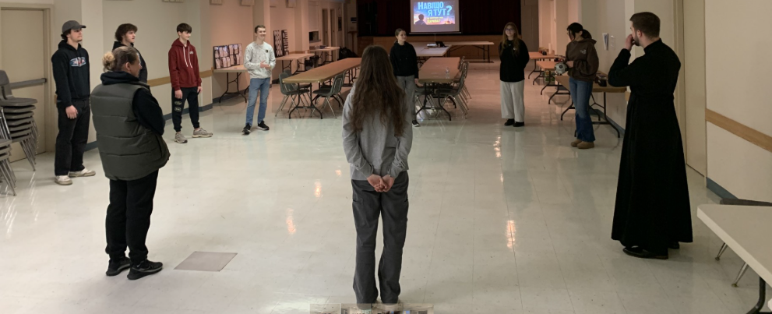

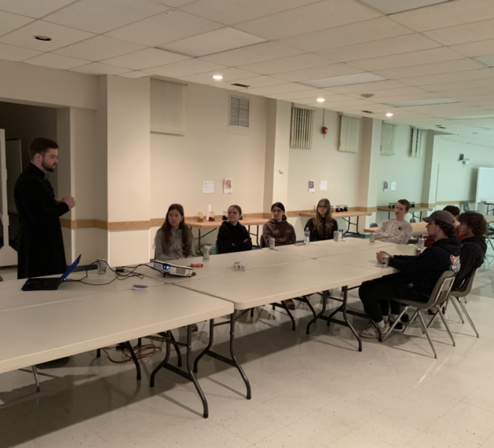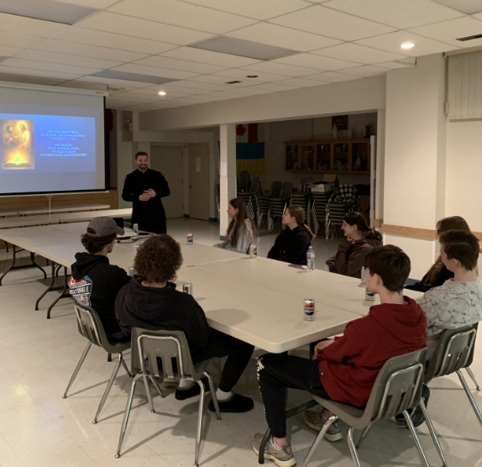

St. Bredan School Kids Mini rethreat and Paska and Pysanka making

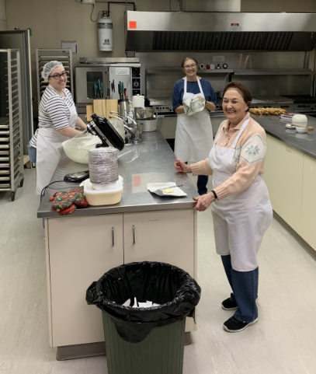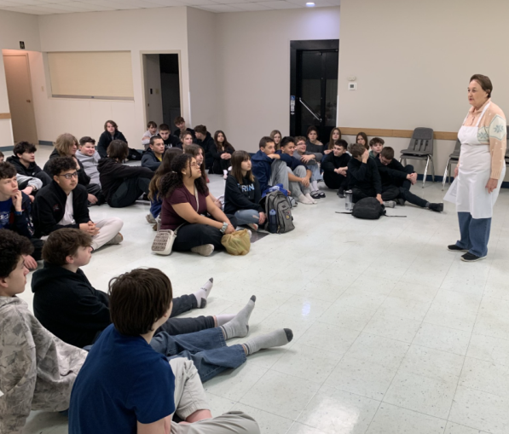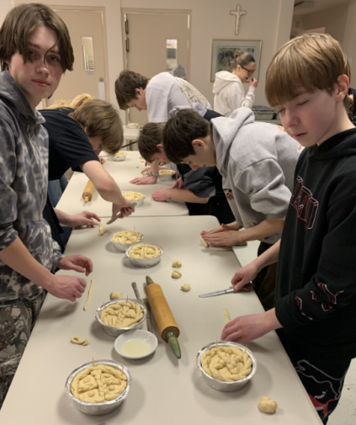

Thank you to all, especially any visitors, for coming and praying with us for first time!
Please come again and become part of our joyful Church family.

Дякуємо всім, особливо ми вдячні тим, що вперше прийшли і молилися разом з нами!
Будь ласка, приходьте знову і станьте частиною нашої церковної родини

Prayer of Saint Ephrem
O Lord and Master of my life! Drive from me the spirit of indifference and discouragement, lust of power, and idle chatter. (Prostration)

Instead, grant to me, Your servant, the spirit of integrity, humility, patience, and love. (Prostration)

Yes, O Lord and King! Let me see my own sins, and not judge my brothers and sisters; for You are blessed, for ever and ever. Amen. (Prostration)

(Then with a simple bow, the following is repeated 4 times)
+ God, be merciful to me a sinner.
+ God, cleanse me of my sins and have mercy on me.
+ I have sinned without number, forgive me, O Lord!

(Once more the entire prayer of St. Ephrem is recited without the usual prostrations. One prostration is made at the conclusion)

Молитва Святого Єфрема
Господи і Владико життя мого! Духа лінивства,
недбайливости, властолюб'я і пустомовства
віджени від мене. (Доземний поклін)
Духа чистоти, покори, терпеливости й любови
даруй мені, слузі твоєму. (Доземний поклін)
Так, Господи, Царю! Дай мені бачити гріхи мої
і не осуджувати брата мого і сестру мою, бо ти благословенний
на віки вічні. Амінь. (Доземний поклін)
(Відтак проказуємо слідуючу молитву 4 рази з метанією)
+ Боже милостивий будь мені грішному!
+ Боже очисти гріхи мої і помилуй мене!
+ Без числа нагрішив(шила) я, Господи прости мені!
(Знову проказуємо молитву св. Єфрема без поклонів. Проказавши молитву робимо ще один поклін)

